Customer Churn Analysis Report
This report presents the exploratory data analysis and data preparation steps undertaken to predict customer churn using various data sets. It includes data collection, visualization, and cleaning processes, providing a foundation for developing a predictive model.

Data Collection and Identification
The following data sets were identified as relevant for predicting customer churn:
- Customer Demographics
- Transaction History
- Customer Service Interactions
- Online Activity
- Churn Status
These data sets provide comprehensive insights into customer behaviour and engagement.

Exploratory Data Analysis
Exploratory data analysis was conducted to uncover patterns and insights that could inform predictive modelling. Key findings include demographic trends, spending patterns, and customer churn rate.

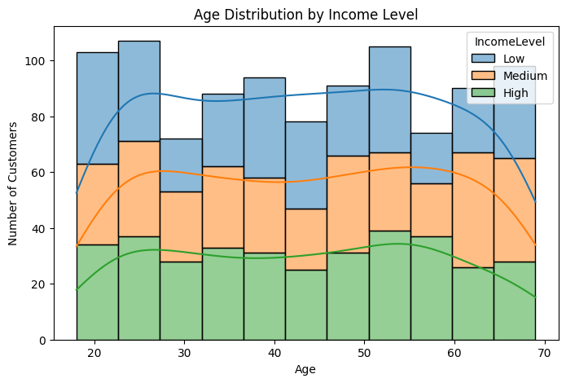

Figure 1: Age Distribution of Customers with their Income level.

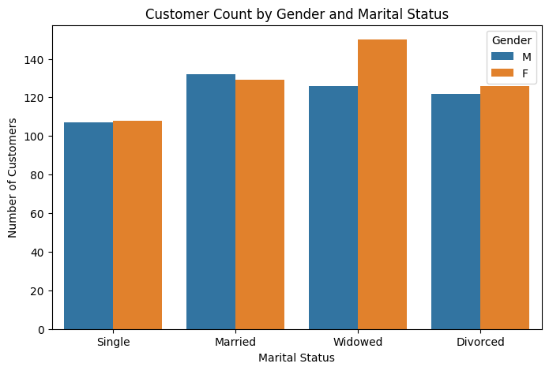

Figure 2: Customer Count by Gender and Marital Status.

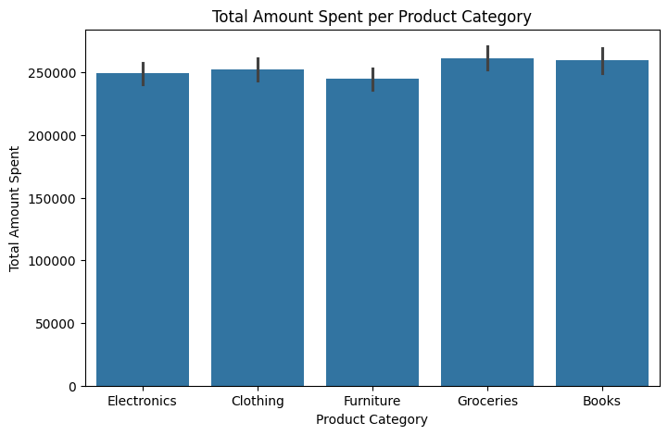

Figure 3: This bar chart shows the total amount spent on each product category.

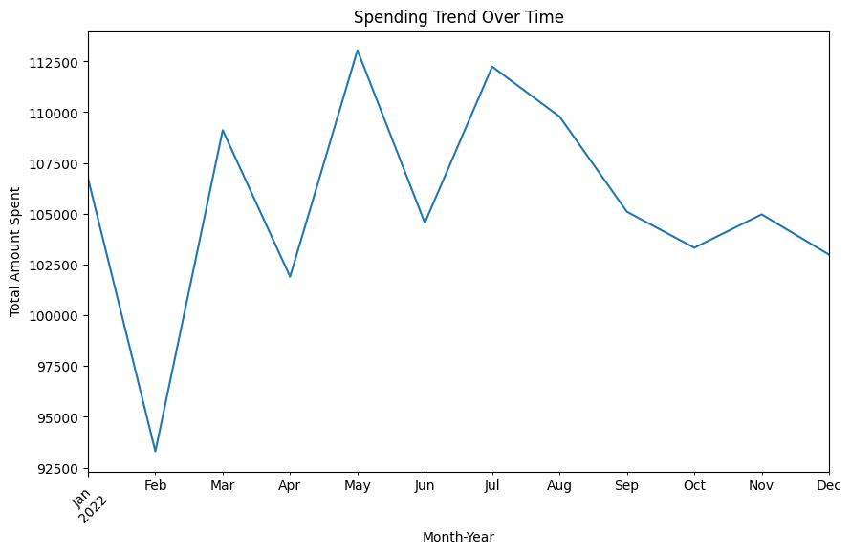

Figure 4: The time series plot shows the level of amount spent for each month throughout the year.

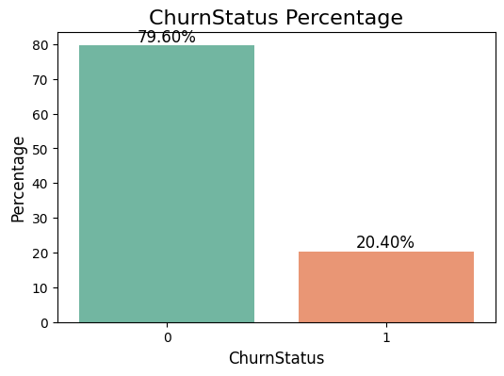

Figure 5: Churn Status Percentage. This bar graph indicate that there are 79.60% of customer retention and 20.40% of customer churn.

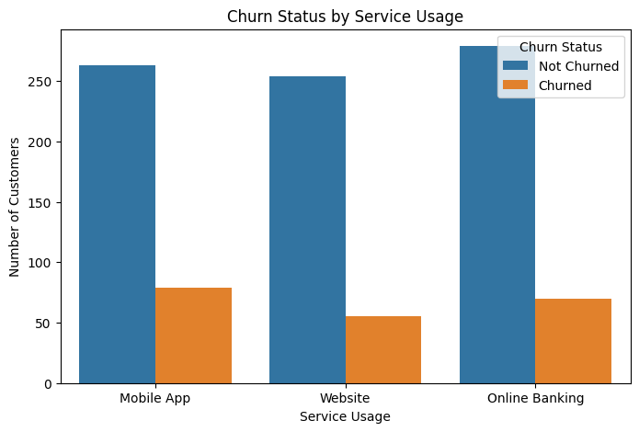

Figure 6: Churn Status by Service Usage. This chart show the number of customers re-tend or churn during each service usage.

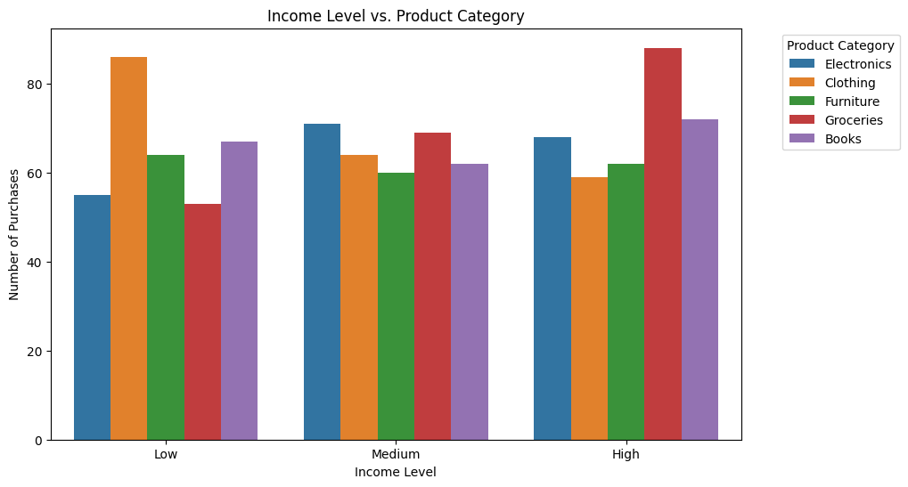

Figure 7: Income Level vs. Product Category. This shows the numbers of product made by each level of income earners.

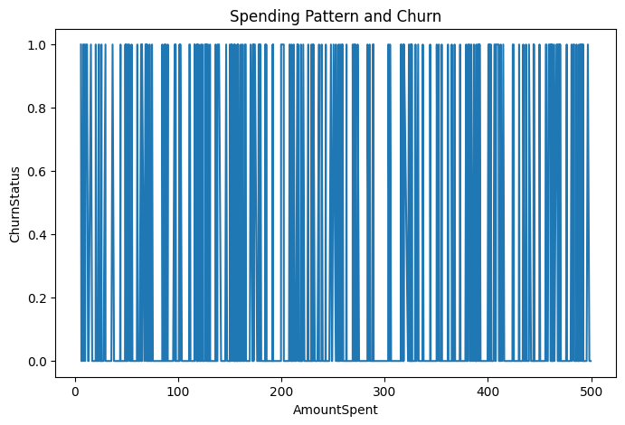

Figure 8: Spending Pattern and Churn Rate.

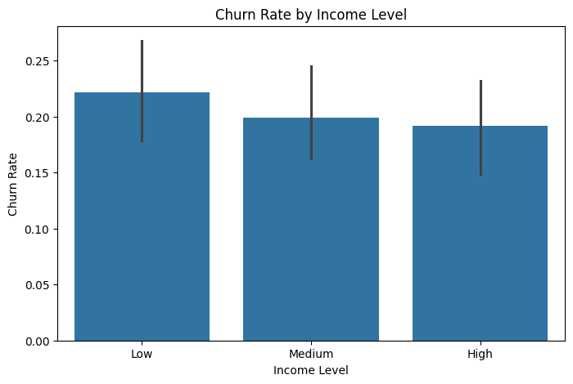

Figure 9: Churn Rate by Income Level. This bar graph indicate that, the low income earners shows the highest rate of churn.

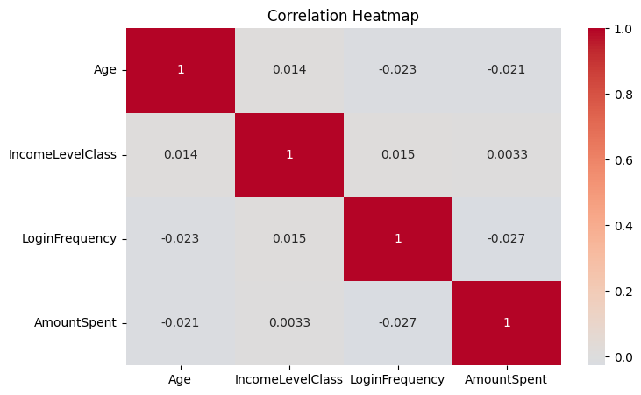

Figure 10: This is a Correlation Heat map for Age, Income Level, Login Frequency and Amount Spent.

Data Cleaning and Preparation
Data cleaning involved handling missing values, detecting and addressing outliers, and normalizing/standardizing numerical features. Categorical features were encoded using one-hot encoding to prepare the data for machine learning algorithms.

